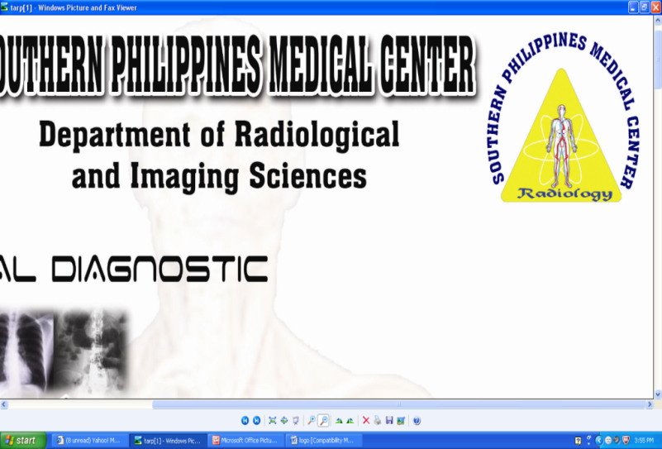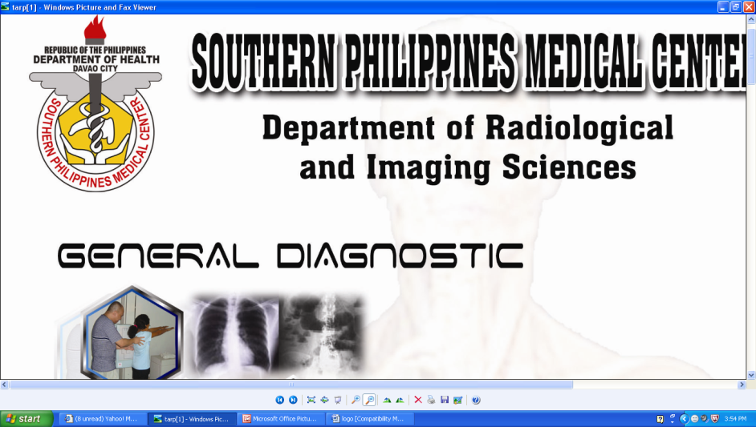SOUTHERN PHILIPPINES MEDICAL CENTER

DEPARTMENT OF RADIOLOGICAL AND IMAGING SCIENCES

JICA Building, SPMC Complex, J.P. Laurel Ave. ,Bajada,Davao City,8000

**MAGNETIC RESONANCE (MR) PROCEDURE SCREENING FORM FOR PATIENTS**

**Date _________/_________/_________ Patient Number______________________**

**Name ____________________________________________________ Age _____ Height ______ Weight _____**

**Last name First name Middle Initial**

**Date of Birth ______/______/______ ___ M ___ F Body Parts to be Examined: ____________________________**

**Month day year**

**Address ___________________________________________________ Contact No: Landline (_____) _______________________**

**City _________________________ Zip Code _____________ Cellphone numbers (_____) _____________**

**Reason for MRI and/or symptoms:_____________________________________________________________________  
Referring Physician _________________________________ Department (______) ___________Contact No:______________**

The MR system has a very strong magnetic field that may be hazardous to individuals entering the MR environment or MR system room if they have certain metallic,electronic,magnetic or mechanical implants, devices or objects. Therefore, all individuals are required to fill out this form **BEFORE** entering the MR environment or MR system room. Be advised, the MR system is **ALWAYS ON.**

|  |  |  |  |
| --- | --- | --- | --- |
| 1. DIAGNOSTIC EXAMS | YES | | NO |
| 1. Have you ever had a MRI examination before   If yes , please indicate:  Type of Examination Date  ____________________________________ __________________________  ____________________________________ __________________________  ____________________________________ __________________________ |  | |  |
| 1. Have you experienced any problem related to previous MRI examination or MR procedure   If yes, please describe: ________________________________________________ |  | |  |
| 1. Have you had prior diagnostic imaging study other than MRI (CT, Ultrasound, X-ray)?   If yes, please list:  Type of Examination Date  ____________________________________ ___________________________  ____________________________________ ___________________________  ____________________________________ ___________________________ |  | |  |
| 1. SURGICAL HISTORY | YES | | NO |
| Have you ever had a surgical operation /procedure of any kind?  If yes, please indicate:  Type of Surgery Date  ____________________________________ ___________________________  ____________________________________ ___________________________  ____________________________________ ___________________________ |  | |  |
| 1. MEDICAL HISTORY | YES | | NO |
| 1. Do you have history of asthma, respiratory disease,anemia or any disease(s) that affect your blood, renal disease, renal failure, renal transplant, high blood pressure,diabeters, liver disease or seizures? If yes, please describe ________________________________________ |  | |  |
| 1. Are you on dialysis? If yes, since when? ___________________________________________ |  | |  |
| 1. Are you currently taking or have you recently taken any medication or drug?   If yes, please list:____________________________________________________________ |  | |  |
| 1. Are you allergic to any medication or contrast dye?   If yes, please indicate ________________________________________________________ |  | |  |
| 1. Are you claustrophobic? |  | |  |
| 1. MEDICAL FOREIGN BODIES | | | |
| Do you have?  **PACEMAKER, DEFIBRILLATOR OR LOOP RECORDER** ANEURYSM CLIPS  NEUROSTIMULATION SYSTEM ELECTRONIC OR MAGNETICALLY-ACTIVATED  SPINAL CORD STIMULATOR IMPLANT OR DEVICE  INTERNAL ELECTRODES OR WIRES BONE GROWTH/BONE FUSION STIMULATOR  HEARING AID,COCHLEAR, OTOLOGIC OR OTHER EAR IMPLANT EYELID SPRING OR WIRE  INSULIN OR OTHER DRUG INFUSION PUMP/DEVICE WIRE MESH IMPLANT  VASCULAR ACCESS PORT AND/OR CATHETER ARTIFICIAL OR PROSTHETIC LIMB  METALLIC STENT , FILTER OR COIL ANY TYPE OF PROSTHESIS ( EYE, HEART VALVE  SHUNT (SPINAL OR INTRAVENTRICULAR SHUNT) PROSTHESIS ,PENILE,ETC)  SWAN-GANZ OR THERMODILUTION CATHETER RADIATION SEEDS OR IMPLANTS  MEDICATION PATCH (NICOTINE,NITROGLYCERINE) RECTAL PROBE  EKG/ECG PADS ON THE BODY | | | |
| 1. TRAUMA/SOCIAL/OCCUPATIONAL HISTORY | YES | | NO |
| Have you ever been injured by a metal object or foreign body  If yes, please describe :    Type of Injury Date  ________________________________________ ___________________________  ________________________________________ ___________________________ |  | |  |
| 1. TRAUMA/SOCIAL/OCCUPATIONAL RELATED FOREIGN BODIES | | | |
| Do you have? ARTIFICIAL OR PROSTHETIC LIMB SURGICAL STAPLES, CLIPS OR METALLIC SUTURES  JOINT REPLACEMENT (HIP,KNEE, ETC.) BONE/JOINT PIN, SCREW, NAIL , WIRE,PLATES  DENTURES OR PARTIAL PLATES TATTOO OR PERMANENT MAKE UP  BODY PIERCING JEWELRY | | | |
| 1. FOR FEMALES | YES | NO | |
| 1. Date of last menstrual period?____________________ Postmenopausal? |  |  | |
| 1. Are you pregnant or suspecting to be pregnant? |  |  | |
| 1. Are you taking any type of fertility medication or having fertility treatments?   If yes, please describe __________________________________________________ |  |  | |
| 1. Do you have IUD or any other internal birth control devices (diaphragm or pessary)? |  |  | |
| 1. Do you have breast implants? |  |  | |
| 1. Are your currently breastfeeding? |  |  | |
| **WARNING**: Certain implants, devices, objects may be hazardous to you in the MR environment or MR system room.  ***DO NOT ENTER THE MRI ROOM IF YOU HAVE ANY QUESTIONS OR CONCERNS REGARDING AN IMPLANT, DEVICE OR***  ***OBJECT***. | | | |

[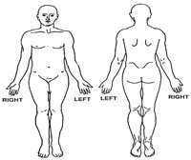](http://www.ajronline.org/cgi/content/full/188/6/1447/FIG3)

*PLEASE MARK ON THE FIGURE (S) BESIDE*

*THE LOCATION OF ANY IMPLANT OR METAL INSIDE OF OR ON YOUR BODY*

I attest that the above information is correct to the best of my knowledge. I read and understand the contents of this form and had the opportunity to ask questions regarding the information on this form and regarding the MR procedure that I am about to undergo.

Form Completed by : ___ Patient _____ Relative Relationship to the Patient _____________________

Name and Signature of Person Completing the Form : ______________________________________________________

**----------------------------------------------------------------------------------------------------------------------------------------------------------------**

***CONSENT FOR THE MRI PROCEDURE***

I HAVE ANSWERED THE QUESTIONS TO THE BEST OF MY ABILITY AND I UNDERSTAND THAT POSSIBLE INJURY COULD RESULT OF MY WITHHOLDING OF VITAL INFORMATIONS.

I CONSENT TO UNDERGO THIS MAGNETIC RESONANCE IMAGING EXAMINATION.

------------------------------------------

Patient Signature/Thumbmark

***----------------------------------------DO NOT FILL UP BELOW THE LINE-----------------------------------------***

***MRI PERSONNEL USE ONLY***

Form Information Reviewed by:

_______________________________________ _______________________________________

MRI Resident-in-Charge MRI RadTech –in-Charge